

QR CODE GENERATOR USING JAVASCRIPT
AN INTERNSHIP

PROJECT REPORT

Submitted by

NARMATHA E

Register No. 312423205144

A report submitted in partial fulfillment of the requirements for the award of Degree of

BACHELOR OF TECHNOLOGY
IN
INFORMATION TECHNOLOGY

ST. JOSEPH'S INSTITUTE OF TECHNOLOGY

JUNE 2025

ST. JOSEPH'S INSTITUTE OF TECHNOLOGY
Semmancheri, Chennai, Tamilnadu, India.

DEPARTMENT OF INFORMATION TECHNOLOGY

BONAFIDE CERTIFICATE

Certified that this project “QR CODE GENERATOR USING JAVASCRIPT” is the bonafide of “NARMATHA E” who carried out the project work under our supervision.

Internship Coordinator Head of the Department
Mr. Mr.
Assistant Professor Assistant Professor
ST. Joseph’s Institute of ST. Joseph’s Institute of
Technology, Technology
Chennai – 119 Chennai - 119

AKCNOWLEDGEMENT

I would like to express my sincere gratitude to all those who have supported and guided me throughout the successful completion of my project titled "QR Code Generator using JavaScript".
First and foremost, I am grateful to my institution and the management for providing me with the opportunity to work on this internship project and enhance my technical skills.
I would like to extend my heartfelt thanks to my project guide, xxxxxxx, for their valuable suggestions, constant encouragement, and constructive feedback throughout the development of this project.
I am also thankful to all the faculty members of the B.Tech IT, who have directly or indirectly helped me during various phases of the project.
Finally, I extend my special thanks to my family and friends for their continuous moral support and motivation.
This project has been a great learning experience, and I am thankful to everyone who contributed to its success.
Thank you.
NARMATHA E

(312423205144)

TABLE OF CONTENTS

Content Page No.
CERTIFICATE
AKCNOWLEDGEMENT
TABLE OF CONTENTS
ABSTRACT 5
CHAPTER 1 COMPANY PROFILE 6
CHAPTER 2 WEEKLY OVERVIEW OF INTERNSHIP ACTIVITIES 8
CHAPTER 3 INTRODUCTION 11
CHAPTER 4 TECHNOLOGY LEARNT 14
CHAPTER 5 SYSTEM SPECIFICATION 16
CHAPTER 6 PROJECT DESCRIPTION 17
CHAPTER 7 CODING 21
CHAPTER 8 RESULTS 22
CHAPTER 9 CONCLUSION 23
CHAPTER 10 24

QR CODE GENERATOR USING JAVASCRIPT

ABSTRACT
This project titled “QR Code Generator using HTML, CSS & JavaScript” is a lightweight and efficient tool that allows users to create QR codes for any text or URL. It uses an external JavaScript library (qrcode.min.js) to convert user input into a scannable QR image, offering an instant preview.

The main goal of this project is to show how simple web technologies can be combined to create a dynamic and useful web application.

CHAPTER 1

COMPANY PROFILE

PCS Software Solutions is an independent software development and training company, driven by industry experts and thought leaders in Web/Mobile development and training domain. We work with some of the smartest software-driven businesses around the world including software product start-ups as well as MNC over 50 companies. We offer Website Development and Hosting Services at affordable price. We develop the Website and as well as take over the responsibility of maintaining your Website PCS offers the most effective and result oriented Digital / Online Marketing Strategies for clients to establish a good image of their brand in the Digital and Social Media. With keen industry expertise and market knowledge, we will analyze the targeted audience to determine the best way of business promotion through Digital Marketing using various Online Promotions in Google, Facebook, Instagram & Youtube Promotions.

VISION:
Be a global force in innovative solutions, quality excellence and redefine creative thoughts. Striving to be a global force in innovative solutions, quality excellence, and the redefinition of creative thoughts, we embark on a journey that transcends boundaries. Our commitment extends beyond mere problem-solving; it encompasses a vision to reshape industries and leave an indelible mark on the global landscape. At the core of our mission is a relentless pursuit of innovation, where we challenge the status quo and push the limits of what is conceivable
MISSION:
We endeavour to bring innovative solutions to the forefront, employing a simple yet effective approach that underscores our commitment to providing deserving quality. Our mission is rooted in a dedication to pushing the boundaries of what's possible, embracing creativity, and maintaining a relentless pursuit of excellence. By adhering to these principles, we aim to not only meet but exceed the expectations of our users, clients, and partners. Through a combination of forward-thinking strategies and a focus on quality, we strive to make a meaningful impact in every endeavour we undertake.
OUR SERVICES
- WEBSITE DEVELOPMENT
- MOBILE APPLICATION DEVELOPMENT
- E-COMMERCE
- WORDPRESS DEVELOPMENT
- OUTSOURCING
- CLOUD SERVICES
- DIGITAL MARKETING
- SEO
- COLLEGE PROJECT
- INTERNSHIP
- SOFTWARE TRAINING

CHAPTER 2

WEEKLY OVERVIEW OF INTERNSHIP ACTIVITIES

1st WEEK | DATE | DAY | NAME OF THETOPIC/MODULE COMPLETED
 | 28/05/2025 | Wednesday | Introduction to HTML, Structure of HTML Page
 | 29/05/2025 | Thursday | HTML Tags: Headings, Paragraph, Links, Images
 | 30/05/2025 | Friday | Lists, Tables, Forms in HTML
 | 02/05/2025 | Monday | Introduction to CSS, Types of CSS (Inline, Internal, External)
 | 03/06/2025 | Tuesday | CSS Selectors, Colors, Text & Font Styling

2nd WEEK | DATE | DAY | NAME OF THETOPIC/MODULE COMPLETED
 | 04/06/2025 | Wednesday | Box Model, Margin, Padding, Border
 | 05/06/2025 | Thursday | CSS Display, Position, Flexbox Basics
 | 06/06/2025 | Friday | Advanced Flexbox Layouts, Responsive Design Basics
 | 09/06/2025 | Monday | Media Queries, Creating a Responsive Web page
 | 10/06/2025 | Tuesday | Mini Project using HTML & CSS – Pet Adoption Website

3rd WEEK | DATE | DAY | NAME OF THETOPIC/MODULE COMPLETED
 | 11/06/2025 | Wednesday | Introduction to JavaScript, Syntax, Variables
 | 12/06/2025 | Thursday | Data types, Operators, Input&Output(alert,console.log)
 | 13/06/2025 | Friday | Conditional Statements(if, if-elsse, switch)
 | 16/06/2025 | Monday | Loops in JavaScript (for, while, do-while)
 | 17/06/2025 | Tuesday | Functions – Declaration, Parameters, Return Values

4th WEEK | DATE | DAY | NAME OF THETOPIC/MODULE COMPLETED
 | 18/06/2025 | Wednesday | Arrays, Objects in JavaScript
 | 19/06/2025 | Thursday | Events in JavaScript (click, change, mouse events)
 | 20/06/2025 | Friday | DOM Manipulation – getElementById, querySelector etc, API,Asyn/Await
 | 23/06/2025 | Monday | Mini Project – QR Code Generator Logic using JS
 | 24/06/2025 | Tuesday | Final Integration – HTML, CSS, JavaScript Project Output

CHAPTER 3

INTRODUCTION

A QR code is a type of matrix bar code or two-dimensional code that can store data information and designed to be read by smartphones. QR stands for “Quick Response” indicating that the code contents should be decoded very quickly at high speed. The code consists of black modules arranged in a square pattern on a white background. The information encoded may be text, a URL or other data.

The QR code was designed to allow its contents to be decoded at high speed. The popularity of QR codes is growing rapidly all around the world. Nowadays, mobile phones with built-in camera are widely used to recognize the QR Codes.

The QR code system was invented in 1994 by Masahiro Hara from the Japanese company Denso Wave. The initial design was influenced by the black and white pieces on a Go board.

3.1Internship Objectives
- Internships are generally thought of to be reserved for college students looking to gain experience in a particular field. However, a wide array of people can benefit from Training Internships in order to receive real world experience and develop their skills.
- An objective for this position should emphasize the skills you already possess in the area and your interest in learning more
- Internships are utilized in a number of different career fields, including architecture, engineering, healthcare, economics, advertising and many more.
- Some internship is used to allow individuals to perform scientific research while others are specifically designed to allow people to gain first-hand experience working.
- Utilizing internships is a great way to build your resume and develop skills that can be emphasized in your resume for future jobs. When you are applying for a Training Internship, make sure to highlight any special skills or talents that can make you stand apart from the rest of the applicants so that you have an improved chance of landing the position.

3.2 MOTIVATION FOR INTERNSHIP

My motivation for this internship was rooted in a desire to learn about web development, gain practical experience, and contribute to meaningful projects. This experience not only aimed to solidify my technical expertise but also to prepare me for a successful career in an ever-evolving technological landscape.

The motivation behind pursuing this internship was driven by my passion for combining front-end technologies like HTML, CSS, and JavaScript to create efficient, secure, and user-friendly Web Applications. In an increasingly interconnected digital world, the synergy between design and functionality is crucial for delivering seamless online experiences. I recognized that gaining practical experience in UI development would be instrumental in advancing my career and contributing meaningfully to the tech industry.

From a web development perspective, my interest in HTML, CSS, and JavaScript stemmed from the desire to build interactive and aesthetically pleasing web interfaces. I also understood that even the most beautifully designed web applications require dynamic functionality powered by scripting languages like JavaScript.

The decision to undertake this internship was further motivated by the opportunity to work in a professional setting, where I could apply my theoretical knowledge to real-world scenarios. I was eager to face the challenges and complexities of integrating UI/UX principles with frontend scripting, learning from industry experts, and gaining hands-on experience with modern tools and frameworks.

Additionally, I was motivated by the prospect of contributing to projects that have a tangible impact on users and organizations. The chance to improve user interaction and design intuitive workflows aligned with my long-term career goals of becoming a proficient frontend developer with a strong foundation in HTML, CSS, and JavaScript.

This internship also offered a platform to develop essential soft skills such as teamwork, problem-solving, and project management. Collaborating with professionals from diverse backgrounds and working on interdisciplinary projects provided a holistic learning experience that extended beyond technical knowledge.

In summary, my motivation for this internship was rooted in a desire to bridge the gap between academic learning and real-world development, gain practical experience, and contribute to meaningful projects that demonstrate my capabilities as a future web developer.

CHAPTER 4
TECHNOLOGIES LEARNT

- HTML (HyperText Markup Language)
- HTML is the standard language used to create the structure of a webpage. It tells the browser what content to display and how the content is arranged (like headings, text boxes, buttons, etc.).
- Used to create the basic structure of the webpage.
- Defined elements such as headings, input fields, containers, and divs for QR code output.
- Ensured semantic and accessible layout for users.

- CSS (Cascading Style Sheets)
- CSS is used to control the appearance and style of the webpage.
- Applied styling to make the webpage visually appealing and user-friendly.
- Used for aligning elements using Flexbox, adding padding, margin, font styling, box shadows, and button hover effects.
- Made the layout responsive across different screen sizes.

- JavaScript
- JavaScript is a scripting language used to add interactivity and dynamic functionality to your website. It responds to user actions (like button clicks or typing).
- Detect when the user enters something in the input field
- Call the generateQr() function to create a QR code
- Show an alert if the input is blank
- Use the external QRCode.js library to convert the input into a QR code image

- QRCode.js (External JavaScript Library)
- QRCode.js is a lightweight JavaScript library used to convert user input into a QR code image.
- It is included using a CDN link and works purely in the browser.
- It allows fast and reliable rendering of QR codes without any server-side processing.
- In this project:
QRCode.js takes the user’s input and instantly generates a scannable QR image inside the browser.

CHAPTER 5

SYSTEM REQUIREMENTS

The software requirement specification can produce at the culmination of the analysis task. The function and performance allocated to software as part of system engineering are refined by established a complete information description, a detailed functional description, a representation of system behavior, and indication of performance and design constrain, appropriate validate criteria, and other information pertinent to requirements.

Software Requirements:
Language : HTML, CSS, JAVASCRIPT
Text Editor : Visual Code
Operating System : Windows 10.
Hardware Requirements:
Processor : Intel core i5
Memory : 8GB RAM
Hard Disk : 1TB

CHAPTER 6
PROJECT DESCRIPTION
This web application is designed to generate a QR Code dynamically based on user input, using core front-end web technologies — HTML, CSS, and JavaScript. It allows users to enter any form of text, such as plain text, URLs, contact information, or other data, into an input field. Once the input is provided, the application generates a QR Code instantly and displays it within the same page.
The layout of the application is clean and simple, consisting of:
- A centered heading that indicates the purpose of the tool (QR Code Generator),
- A user-friendly text input field where the user can type or paste content,
- A dedicated QR code display area (<div class="qrcode">) where the generated image is shown,
- Error validation to ensure the input is not empty before attempting to generate the QR code.
The application uses the QRCode.js library, a lightweight and widely used JavaScript library for QR code generation. This library is loaded via a CDN (Content Delivery Network), which makes it easy to integrate without requiring installation or external dependencies. It efficiently converts the provided input into a machine-scannable QR code that can be read by any smartphone or QR scanner.
Additionally, the JavaScript function generateQr() handles the logic of checking the input field for empty values, and if valid, generates the QR code using the library. This ensures real-time feedback for the user while maintaining performance and responsiveness.
One of the biggest advantages of this project is that it runs entirely on the client-side — no server or backend processing is needed. It works seamlessly in all modern browsers, making it accessible and platform-independent. This type of tool can be practically useful in various industries, including marketing, education, event management, and more — wherever quick digital linking is needed.
In summary, this project demonstrates how simple web technologies can be effectively combined to create an interactive and useful tool that reflects real-world application development practices.

BACKGROUND

A QR Code consists of black squares and dots arranged in a square grid with white background (most commonly). Every QR-Code is unique, which can be processed using Reed-Solomon error correction, already available in our smartphone camera. One only needs to open their mobile camera and place it over any QR Code, it will automatically interpret it and show you the content it is meant to show. A QR-Code stores data in numeric, alphanumeric, byte/binary and kanji format.

QR-Code has a wide range of applications like product tracking, time tracking, item identification, document identification, and linking content. It can also work on an access control solution to allow entry after scanning a QR-Code. At this time when more and more priority is given to contactless access, QR-Code can be a solution for access control.

Applications Of QR Code

Direct customers to a landing page:- Through the usage of QR Codes, it becomes convenient to guide customers to the landing page of your website just by scanning a code. Over time this has proved to be an effective marketing technique.

Download apps:- The play store gives you a unique code for your app which you can tag along with any advertisement campaign which directs potential users to download your app. This could drive downloads for a business.

Add locations:- Individuals can also add the location of their shop, office, home or any other place to a QR Code for simpler navigation of individuals.

For ordering:- Restaurant can attach their menu to a QR code on every table through which customers can order directly.

Act as an access control system:- Individuals can attach a QR code at the door or any entry point which will allow a person to enter after scanning the code by unlocking or sending any OTP for entry.

Networking:- Individuals can easily share their user ID with someone they recently connected by giving them the QR code of their social profile.

Different applications of QR Codes like website URL, Application downloads, add locations, access control system, networking, etc.

There are mainly 6 reasons why a QR Code does not work:
1. Bad quality
2. Inverted colors
3. Small size
4. Poor contrast ratio
5. Wrong Placement
6. Overcrowded QR Code

Existing System:
In Existing system have some challenges, which are,
- The usage of several algorithms has been made the system's functioning complex.
- QR codes that are dynamic are used
- Dedicated storage increases spending

Proposed System:

A free QR code generator online encodes information into a QR code. Often that means turning a link into a QR code. You upload information onto the website, and the website spits out a QR code. That QR code links out to a URL, a PDF, or the other information you uploaded. In this project we can generate qr code of names, numbers and url. we can also scan the qr code with specific scanner for qr code generated by text or etc,

CHAPTER 7
CODING

<!--Index.html-->
<!DOCTYPE html>
<html lang="en">
<head>
<link rel="stylesheet" href="./style.css" />

<!-- External QR code library -->
<!--This is the liberary which helps
to convert simple data to the images-->
<script src=
"https://cdnjs.cloudflare.com/ajax/libs/qrcodejs/1.0.0/qrcode.min.js">
</script>
</head>
<body>
<div class="header">
<div class="box">
<h1>
QR Code Generator
</h1>
<hr />
<div class="sqrcode"></div>
<div class="qrcode"></div>
<input type="text"
placeholder="Paste a URL or enter
text, then press enter"
onchange="generateQr()" />
<!--generateQr() is the fuction which helps
to convert data into QR using the js library-->
</div>
</div>
<script src="./script.js"></script>
</body>
</html>

CHAPTER 8
RESULTS
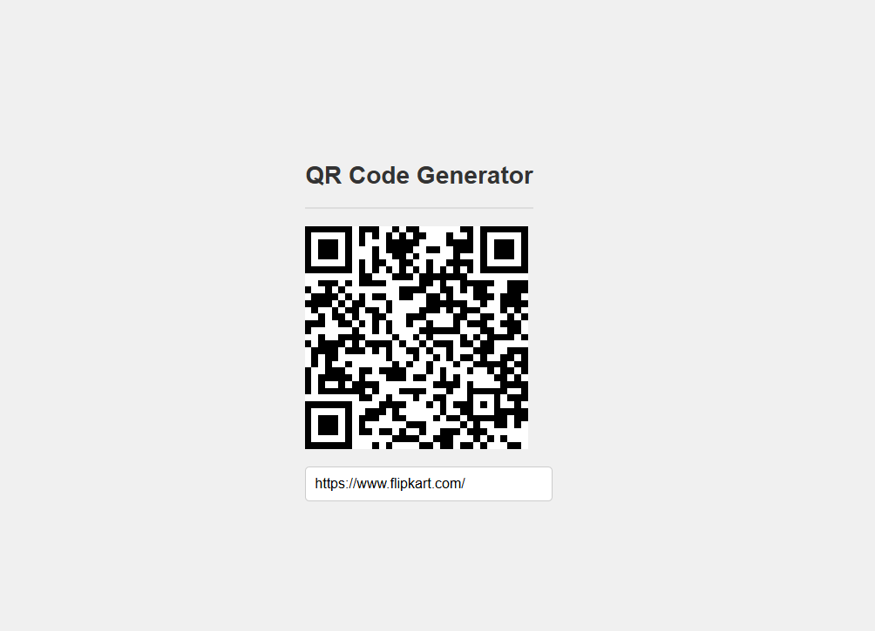

CHAPTER 9

CONCLUSION

QR code is now being widely used in a variety of businesses. QR code is a way of encoding more information than a traditional bar code. And most importantly, it contains information that can be easily decoded at high speed. In this paper, we show how to create the QR codes via the web browser that facilitates users to easily create their own QR codes for websites, emails, business cards, print ads and so on.

The experimental results show that the QR codes were successfully and correctly generated. Therefore, the proposed method is considerably a QR code generator collaborative tools that is available for free use We studied QR code technology, its benefits, application areas, and its impact on marketing and technological world. Initially, QR code are developed and use for inventory tracking stuff but, now these days, they found applications in many new areas like marketing, advertising, secure payment systems, education industries, etc.

CHAPTER 10

REFERENCES

• https://github.com/davidshimjs/qrcodejs
• https://www.w3schools.com/
• https://developer.mozilla.org/

